**MINISTRY OF EDUCATION AND TRAINING**

**FPT UNIVERSITY**

Capstone Project Document

**In-store Customer Heatmap System**

|  |  |
| --- | --- |
| **Group 07** | |
| **Group members** | Vũ Tấn Huy – SE62172  Đỗ Quốc Cường – SE62573  Nguyễn Quang Tuyến – SE62069  Đinh Hoàng Phúc – SE61768 |
| **Supervisor** | Lâm Hữu Khánh Phương |
| **Ext. Supervisor** | N/A |
| **Capstone Project code** | ICHS |

Ho Chi Minh City, 3th May 2019

**Contents**

**List of Figures** 4

**List of Tables** 5

**A.** **CAPSTONE PROJECT REGISTER** 6

**1.** **Register information for supervisor (if have)** 6

**2.** **Register information for students (if have)** 6

**3.** **Register content of Capstone Project** 6

**3.1.** **Capstone Project name:** 6

**3.2.** **Main proposal content (including result and product)** 7

**4.** **Other comment (propose all relative thing if have)** 7

**B.** **INTRODUCTION** 7

**1.** **Project Information** 7

**2.** **Introduction** 8

**3.** **Current Situation** 8

**4.** **Problem Definition** 8

**5.** **Proposed Solution** 8

**5.1. Feature functions** 8

**5.2. Advantages and disadvantages** 9

**6.** **Functional Requirement** 9

**7.** **Role and Responsibilities** 9

**C.** **SOFTWARE PROCESS MODEL** 10

**D.** **CONCEPTUAL DIAGRAM** 10

**E.** **USE CASE DIAGRAM** 12

**F.** **USE CASE SPECIFICATION** 13

**1.** **<User> View Store** 13

**2.** **<User> View Zone** 14

**3.** **<User> View Camera** 16

**4.** **<User> View Streaming Camera** 17

**5.** **<User> See Object Detection** 19

**6.** **<User> See Count People** 21

**7.** **<User> See Face Detection** 23

**8.** **<User> View Stream Heatmap** 24

**9.** **<User> View Report** 26

**10.** **<User> Preview heatmap in time** 28

**G.** **ARCHITECTURAL DIAGRAM** 30

**H.** **COMPONENT DIAGRAM** 31

**I.** **CLASS DIAGRAM** 32

**J.** **ENTITY RELATIONSHIP DIAGRAM** 33

**K.** **INTERACTION DIAGRAM** 34

**1.** **Login** 34

**2.** **Create Company** 35

**3.** **Update Company** 35

**4.** **Activate Company** 36

**5.** **Deactivate Company** 36

**6.** **Search Company** 37

**7.** **Get report camera by time** 37

**8.** **Get report zone by time** 38

**9.** **Get report store by time** 38

**L.** **PHYSICAL DIAGRAM** 39

**M.** **ARCHITECTURAL DIAGRAM FRAMEWORK** 40

**N.** **ALGORITHMS** 41

**1.** **Faster RCNN** 41

**1.1** **Definition** 41

**1.2** **Define problems** 41

**1.3** **Solution** 41

**2.** **Draw Heatmap** 43

**2.1** **Definition** 43

**2.2** **Define problem** 43

**2.3** **Solution** 43

**3.** **Face Detection** 44

**3.1** **Definition** 44

**3.2** **Define problem** 44

**3.3** **Solution** 44

**O.** **FUTURE PLAN** 45

**P.** **DIAGRAM EXPLANATION** 45

**1.** **CLASS DIAGRAM EXPLANATION** 45

**1.1** **Account** 45

**1.2** **Company** 46

**1.3** **Store** 46

**1.4** **Zone** 47

**1.5** **Camera** 47

**1.6** **Report** 48

**1.7** **Traffic** 48

# **List of Figures**

Figure 1 : Waterfall model 10

Figure 2 : Conceptual Diagram 10

Figure 3 : Use Case Diagram 12

Figure 4 : <User> View Store 13

Figure 5 : <User> View Zone 14

Figure 6 : - <User> View Camera 16

Figure 7 : <User> View Streaming Camera 17

Figure 8 : <User> See Object Detection 19

Figure 9 : <User> See Count People 21

Figure 10 : <User> See Face Detection 23

Figure 11 : <User> View Stream Heatmap 24

Figure 12 : <User> View Report 26

Figure 13 : <User> View Heatmap 28

Figure 14 : Architectural Diagram 30

Figure 15 : Component Diagram 31

Figure 16 : Class Diagram 32

Figure 17 : Entity Relationship Diagram 33

Figure 18 : Sequence Diagram <Login> 34

Figure 19 : Sequence Diagram <Create Company> 35

Figure 20 : Sequence Diagram <Update Company> 35

Figure 21 : Sequence Diagram <Activate Company> 36

Figure 22 : Sequence Diagram <Deactivate Company> 36

Figure 23 : Sequence Diagram <Search Company> 37

Figure 24 : Sequence Diagram <Get report camera by time> 37

Figure 25 : Sequence Diagram <Get report zone by time> 38

Figure 26 : Sequence Diagram <Get report store by time> 38

Figure 27 : Physical Diagram 39

Figure 28 : Architectural Diagram Framework 41

Figure 29 : Faster RCNN 1 42

Figure 30 : Faster RCNN 2 43

Figure 31 : Draw Heatmap <Dot Image> 43

Figure 32 : Draw Heatmap <Color Range> 43

Figure 33 : Draw Heatmap <Heatmap Color Image> 44

Figure 34 : Face Detection 44

Figure 35 : Face Detection <Haar-Like> 1 44

Figure 36 : Face Detection <Haar-Like> 2 45

# **List of Tables**

Table 1 : Register information for supervisor 6

Table 2 : Register information for students 6

Table 3 : Role and responsibilities 9

Table 4 : Conceptual Diagram Dictionary 11

Table 5 : <User> View Store 14

Table 6 : <User> View Zone 15

Table 7 : <User> View Camera 17

Table 8 : <User> View Streaming Camera 19

Table 9 : <User> See Object Detection 20

Table 10 : <User> See count people 22

Table 11 : <User> See Face Detection 24

Table 12 : <User> View Stream Heatmap 26

Table 13 : <User> View Report 27

Table 14: <User> Preview heatmap in Time 29

Table 15 : Component Diagram Dictionary 31

Table 16 : Class Diagram Dictionary 33

Table 17 : Entity Relationship Diagram Dictionary 34

Table 18 : Physical Diagram Dictionary 40

Table 19 : Class Diagram Explanation <Account> 46

Table 20 : Class Diagram Explanation <Company> 46

Table 21 : Class Diagram Explanation <Store> 47

Table 22 : Class Diagram Explanation <Zone> 47

Table 23 : Class Diagram Explanation <Camera> 48

Table 24: Class Diagram Explanation <Report> 48

Table 25: Class Diagram Explanation<Traffic> 49

# **CAPSTONE PROJECT REGISTER**

(*) Profession: <Software Engineer> Specialty: <ES> <IS> <JS>

x

(*) Kinds of person make registers: Lecturer Students

x

## **Register information for supervisor (if have)**

|  |  |  |  |  |
| --- | --- | --- | --- | --- |
|  | **Full name** | **Phone** | **E-Mail** | **Title** |
| Supervisor 1 | Lâm Hữu Khánh Phương | 0915353001 | [phuonglhk@fpt.edu.vn](mailto:phuonglhk@fpt.edu.vn) | Mr. |

Table : Register information for supervisor

## **Register information for students (if have)**

|  |  |  |  |  |  |
| --- | --- | --- | --- | --- | --- |
|  | **Full name** | **Student code** | **Phone** | **E-mail** | **Role in Group** |
| Student 1 | Vũ Tấn Huy | SE62172 | 0909679977 | huyvtse62176@fpt.edu.vn | Leader |
| Student 2 | Đỗ Quốc Cường | SE62573 | 0904635563 | cuongdqse62573@fpt.edu.vn | Member |
| Student 3 | Nguyễn Quang Tuyến | SE62069 | 0969694629 | tuyennqse62069@fpt.edu.vn | Member |
| Student 4 | Đinh Hoàng Phúc | SE61768 | 0764038298 | phucdhse61768@fpt.edu.vn | Member |

Table : Register information for students

## **Register content of Capstone Project**

### **Capstone Project name:**

* English: In-Store Customer Heatmap System
* Vietnamese: Xây dựng biểu đồ nhiệt khách hàng trong cửa hàng.
* Abbreviation: ICHS

### **Main proposal content (including result and product)**

1. Theory and practice (document):

* Student should apply the software development process and UML 2.0 in modelling system.
* The documents include User Requirement, Software Requirement Specification, Architecture Design, Detail Design, System Implementation and Testing Document, Installation Guide, sources code, and deployable software packages
* Server side technologies:
  + Server: .NET, Java or Javascript, Windows Azure…
  + Database Design: SQL Server or MySQL.
* Client side technologies:
  + Web Client: HTML5, CSS3, JavaScript.

1. Program:

Build a system with features:

* Feature 1: Cloud server for storing video data from store
* Feature 2: Evaluate and implement people counting algorithm on video
* Feature 3: Measure store traffic in real time and show on heat map (update data every 30s)
* Feature 4: Reporting data: number of passersby from the zone, average shopping time, Historical reports at hourly & daily intervals.

Hardware and software: camera support RTSP protocol, Windows or Linux server.

## **Other comment (propose all relative thing if have)**

There is no records kept about shopper‘s identity without their permissions, so no privacy concerns on this solutions.

# **INTRODUCTION**

1. **Project Information**

- Project name: **In-Store Customer Heatmap System**

- Project Code: **ICHS**

- Project Type: **Web Application**

- Start Date: 03/05/19

- End Date: 27/08/19

1. **Introduction**

In this project, we will introduce a solution in store data analysis. In the current era, information or data is always very important and useful in many fields, especially in analysis.

Our web is using technologies to make data’s analysis easier for users to manage or analyze, in which the camera supports RTSP protocol that supports converting video to the heatmap form shown on screen.

Through this web, along with the features it offers, the team wants to help managers or shop owners have a view of customer’s behavior that they can change their store and make it better.

1. **Current Situation**

Currently, the use of shop's security cameras is simply used for monitoring purposes and when problems arise, the videos will be extracted. This inadvertently wastes the amazing effects that the camera offers. What the current camera offers is just quite difficult to exploit all that data effectively.

Nowadays, when information technology is very popular, AI (Artificial Intelligence) is also one of the things that are very interested. So, combining cameras with an AI-based application that helps users to make the most of the benefits of the camera is really a good idea.

1. **Problem Definition**

* Applications included with the camera are usually only used for streaming and video playback.
* Streaming is mainly used for monitoring purposes.
* The extracted videos do not bring much value for analysis.
* Do not bring the most of the benefits that the camera offers.

1. **Proposed Solution**

Our Proposed Solution is to build a system named In-Store Customer Heatmap System (ICHS), a Web application where users can view stream videos in the heatmap mode and people detection mode, can know the density of zones, count the number of people ... from there, based on reports, they are able to make assessments or reasonable changes.

**5.1. Feature functions**

- Web application: Help user view streaming camera and see customer’s behavior.

* Video streaming: watch real-time streaming camera in website.
* See Detect people on video: see how to detect people in real-time streaming camera.
* See people counting on video: see count the result of people detection.
* See heatmap: see heatmap in real-time streaming video.
* See people analysis: see face analysis in real-time streaming video.
* Preview heatmap in time: see heatmap in each hour.
* Get report: report how many people in each time and how long people stay in each place.
* Web admin: Help admin to manage system.
* Manage company, account, store, zone, camera.

- RTSP server: Get video steaming in camera and analyze it.

* Get camera streaming: use RTSP to take camera view.
* Detect people: detect people and where people are.
* Draw heatmap: base on result of detection and draw heatmap.
* Detect Face: detect face people and get their information.

**5.2. Advantages and disadvantages**

Advantages

* System allows user see streaming camera in website.
* System can detect people and behavior to make a report for user.
* System allows user to see store/shop heatmap that can change product or style.

Disadvantages

* Don’t have many people know about heatmap

1. **Functional Requirement**

Function requirements of the system are listed as below:

- User component:

* View Streaming camera.
* View result of detect, heatmap.
* Preview heatmap in time.
* View report.
* Admin component:
* Manage company, store, zone, camera.
* RTSP server component:
* Get streaming camera.
* Detect people.
* Draw heatmap.
* Analyze face.
* Save video.
* Upload video in cloud.

1. **Role and Responsibilities**

|  |  |  |  |  |
| --- | --- | --- | --- | --- |
| **No** | **Full Name** | **Role** | **Position** | **Contact** |
| **1** | Mr. Lâm Hữu Khánh Phương | Project Manager | Supervisor | phuonglhk@fpt.edu.vn |
| **2** | Vũ Tấn Huy | Developer | Leader | huyvtse62176@fpt.edu.vn |
| **3** | Đỗ Quốc Cường | Developer | Member | cuongdqse62573@fpt.edu.vn |
| **4** | Nguyễn Quang Tuyến | Developer | Member | tuyennqse62069@fpt.edu.vn |
| **5** | Đinh Hoàng Phúc | Developer | Member | phucdhse61768@fpt.edu.vn |

Table : Role and responsibilities

# **SOFTWARE PROCESS MODEL**

The software process model used in developing is based on the Waterfall model.

Reasons we choose this:

* RTSP server architecture need to be designed to make it fast as much as possible.
* The requirements are not often change.



Figure : Waterfall model

# **CONCEPTUAL DIAGRAM**

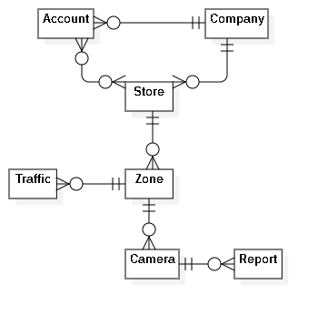

Figure : Conceptual Diagram

|  |  |
| --- | --- |
| **Entity Data dictionary: describe all content of all entities** | |
| **Entity Name** | **Description** |
| Account | Contains the account information. |
| Company | Contains the company information. |
| Store | Contains the store information. |
| Zone | Contains the zone information. |
| Camera | Contains the camera information. |
| Report | Contains the report information. |
| Traffic | Contains the traffic information. |

Table : Conceptual Diagram Dictionary

# **USE CASE DIAGRAM**

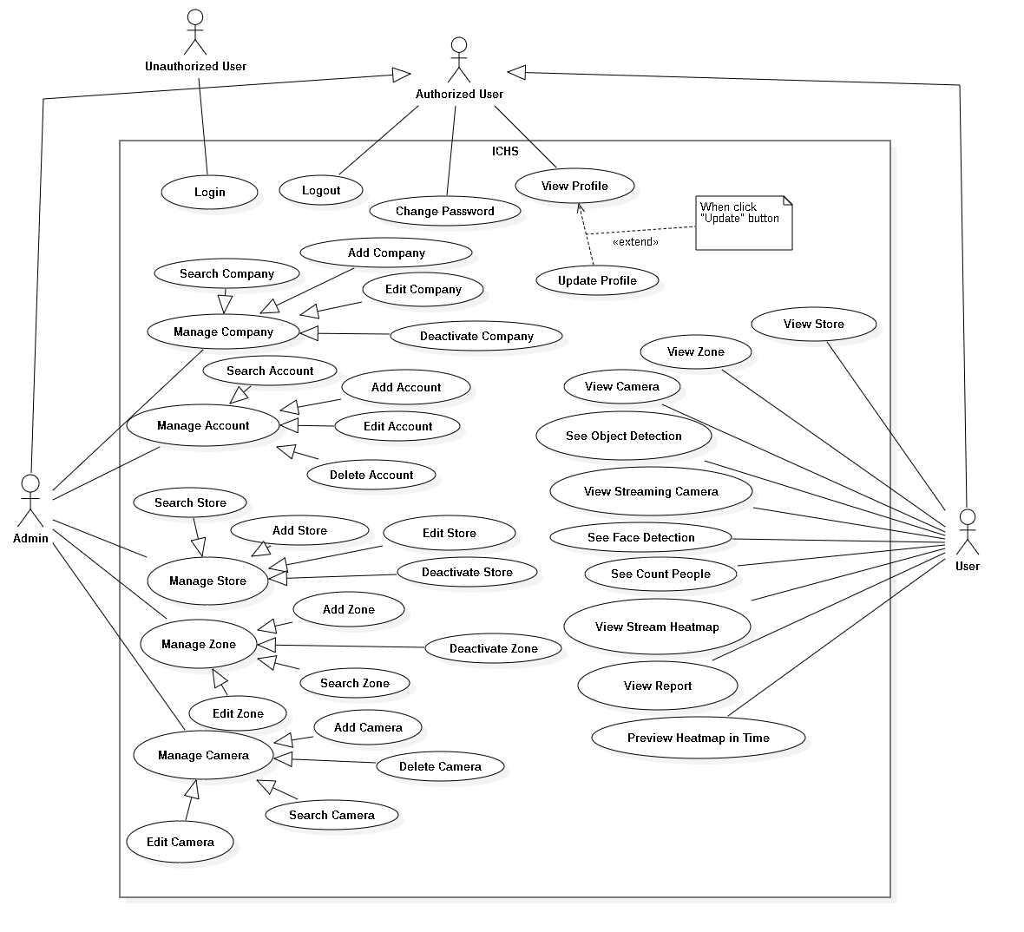

Figure : Use Case Diagram

# **USE CASE SPECIFICATION**

## **<User> View Store**

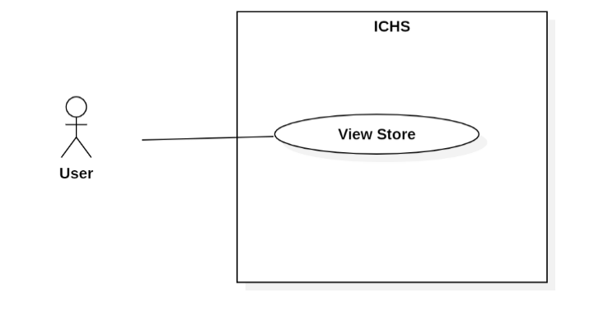

Figure : <User> View Store

|  |  |  |  |
| --- | --- | --- | --- |
| **USE CASE – UC_26** | | | |
| **Use Case No.** | 26 | **Use Case Version** | 1.0 |
| **Use Case Name** | View Store | | |
| **Author** | HuyVT | | |
| **Date** | 08/08/2018 | **Priority** | Normal |
| **Actor:**   * User   **Summary:**   * This use case allows the user view store of company.   **Goal:**   * User view all stores within the limits allowed by the admin.   **Triggers:**   * User clicks “Store” button.   **Preconditions:**   * User login successful with account provided by the admin.   **Post Conditions:**   * **Success:** show all store with account user. * **Fail:** System shows error message.   **Main Success Scenario:**   |  |  |  | | --- | --- | --- | | **Step** | **Actor Action** | **System Response** | | 1 | User goes to dashboard page and click “store” button. | System show all store with account user.  [Exception 1] |   **Alternative:** N/A.  **Exceptions:**   |  |  |  | | --- | --- | --- | | **No** | **Cause** | **System Response** | | 1 | Network problem. | System shows error message. |   **Relationships:** N/A.  **Business Rules:** N/A. | | | |

Table : <User> View Store

## **<User> View Zone**

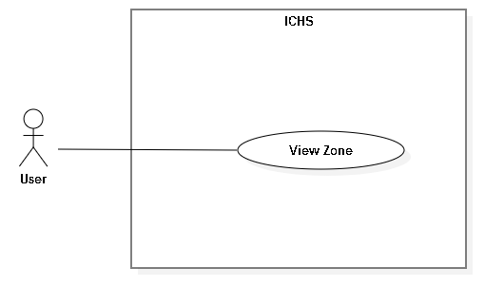

Figure : <User> View Zone

|  |  |  |  |
| --- | --- | --- | --- |
| **USE CASE – UC_27** | | | |
| **Use Case No.** | 27 | **Use Case Version** | 1.0 |
| **Use Case Name** | View Zone | | |
| **Author** | TuyenNQ | | |
| **Date** | 08/08/2019 | **Priority** |  |
| **Actor:**   * User   **Summary:**   * This use case allows the user to view all zones in one store.   **Goal:**   * User view all zones in one store.   **Triggers:**   * User clicks “Store” button. * User clicks “View Zone” button. * User sends view zone command.   **Preconditions:**   * User login successful with account provided by the admin. * User is at the chosen store page.   **Post Conditions:**   * **Success:** User view all zones. * **Fail:** System shows error message.   **Main Success Scenario:**   |  |  |  | | --- | --- | --- | | **Step** | **Actor Action** | **System Response** | | 1 | User goes to dashboard page and click “store” button. | System show all store with account user. | | 2 | User clicks “Zone” button in Store page. | System displays the “Zone” page and shows zones.  [Exception 1] |   **Alternative:** N/A.  **Exception:**   |  |  |  | | --- | --- | --- | | **No** | **Cause** | **System Response** | | 1 | Network problem. | System shows error message. |   **Relationships:** N/A.  **Business Rules:** N/A. | | | |

Table : <User> View Zone

## **<User> View Camera**

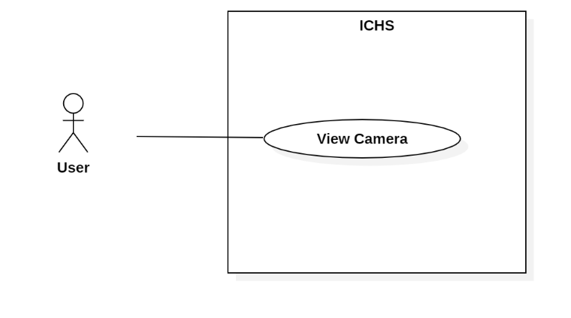

Figure : - <User> View Camera

|  |  |  |  |
| --- | --- | --- | --- |
| **USE CASE – UC_28** | | | |
| **Use Case No.** | 28 | **Use Case Version** | 1.0 |
| **Use Case Name** | View Camera | | |
| **Author** | TuyenNQ | | |
| **Date** | 08/08/2019 | **Priority** |  |
| **Actor:**   * User   **Summary:**   * This use case allows the user to view all cameras in one zone.   **Goal:**   * User view all cameras in one zone that user choosen.   **Triggers:**   * User clicks “Store” button * User clicks “View zone” button. * User clicks “Camera” button. * User sends view camera command.   **Preconditions:**   * User login success. * User is at the chosen zone page.   **Post Conditions:**   * **Success:** User view all cameras. * **Fail:** System shows error message.   **Main Success Scenario:**   |  |  |  | | --- | --- | --- | | **Step** | **Actor Action** | **System Response** | | 1 | User goes to dashboard page and click “store” button. | System show all store with account user. | | 2 | User clicks “Zone” button in Store page. | System shows the “Zone” page and shows zones. | | 3 | User clicks “Camera” button in Zone page. | System shows the “Camera” page and shows cameras.  [Exception 1] |   **Alternative:** N/A.  **Exception:**   |  |  |  | | --- | --- | --- | | **No** | **Cause** | **System Response** | | 1 | Network problem. | System shows error message. |   **Relationships:** N/A.  **Business Rules:** N/A. | | | |

Table : <User> View Camera

## **<User> View Streaming Camera**

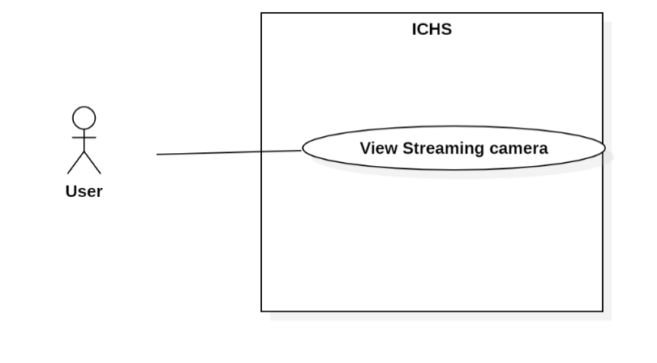

Figure : <User> View Streaming Camera

|  |  |  |  |
| --- | --- | --- | --- |
| **USE CASE – UC_29** | | | |
| **Use Case No.** | 29 | **Use Case Version** | 1.0 |
| **Use Case Name** | View Streaming Camera | | |
| **Author** | TuyenNQ | | |
| **Date** | 08/08/2019 | **Priority** |  |
| **Actor:**   * User   **Summary:**   * This use case allows the user to view the streaming video from the selected camera.   **Goal:**   * User view streaming video from camera.   **Triggers:**   * User clicks on “View zone” button. * User clicks on “View camera” button. * User sends view streaming camera command.   **Preconditions:**   * User login success. * User is at “Camera” page.   **Post Conditions:**   * **Success:** User view streaming camera. * **Fail:** System displays error message.   **Main Success Scenario:**   |  |  |  | | --- | --- | --- | | **Step** | **Actor Action** | **System Response** | | 1 | User clicks on “View” button on store page. | System shows list all zone in store. | | 2 | User clicks on “View” button on zone page. | System shows list all camera in zone. | | 3 | User click on “View” button on camera detail page. | System shows camera.  [Exception 1] |   **Alternative:** N/A.  **Exception:** N/A.   |  |  |  | | --- | --- | --- | | **No** | **Cause** | **System Response** | | 1 | Network problem. | System shows error message. |   **Relationships:** N/A.  **Business Rules:** N/A. | | | |

Table : <User> View Streaming Camera

## **<User> See Object Detection**

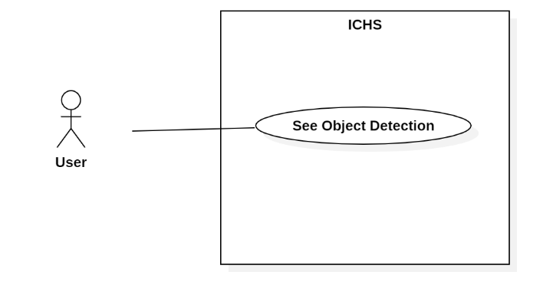

Figure : <User> See Object Detection

|  |  |  |  |
| --- | --- | --- | --- |
| **USE CASE – UC_30** | | | |
| **Use Case No.** | 30 | **Use Case Version** | 1.0 |
| **Use Case Name** | See Object Detection | | |
| **Author** | TuyenNQ | | |
| **Date** | 08/08/2019 | **Priority** |  |
| **Actor:**   * User   **Summary:**   * This use case allows the user to see the object detection in streaming video from the selected camera.   **Goal:**   * User see object detection in streaming video.   **Triggers:**   * User clicks on “View zone” button. * User clicks on “View camera” button. * User clicks the switch button in streaming video page. * User sends see object detection command.   **Preconditions:**   * User login success. * User is at “Camera Detail” page.   **Post Conditions:**   * **Success:** User see count people. * **Fail:** System shows error message.   **Main Success Scenario:**   |  |  |  | | --- | --- | --- | | **Step** | **Actor Action** | **System Response** | | 1 | User clicks on “View” button on store page. | System shows list all zone in store. | | 2 | User clicks on “View” button on zone page. | System shows list all camera in zone. | | 3 | User click on “View” button on camera detail page. | System shows camera. | | 4 | User clicks “Object Detection” button. | System shows box in the video with count people.  [Exception 1] |   **Alternative:** N/A.  **Exception:**   |  |  |  | | --- | --- | --- | | **No** | **Cause** | **System Response** | | 1 | Network problem. | System shows error message. |   **Relationships:** N/A  **Business Rules:** N/A. | | | |

Table : <User> See Object Detection

## **<User> See Count People**

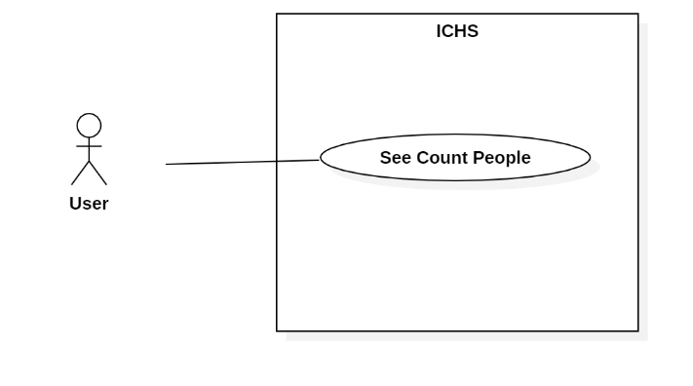

Figure : <User> See Count People

|  |  |  |  |
| --- | --- | --- | --- |
| **USE CASE – UC_31** | | | |
| **Use Case No.** | 31 | **Use Case Version** | 1.0 |
| **Use Case Name** | See Count People | | |
| **Author** | TuyenNQ | | |
| **Date** | 08/08/2019 | **Priority** |  |
| **Actor:**   * User   **Summary:**   * This use case allows the user to see the people counting in streaming video from the selected camera.   **Goal:**   * User see count people in streaming video.   **Triggers:**   * User clicks on “View zone” button. * User clicks on “View camera” button * User clicks the switch button in streaming video page. * User sends see count people command.   **Preconditions:**   * User login success. * User is at” Camera” page.   **Post Conditions:**   * **Success:** User view streaming camera. * **Fail:** System displays error message.   **Main Success Scenario:**   |  |  |  | | --- | --- | --- | | **Step** | **Actor Action** | **System Response** | | 1 | User clicks on “View” button on store page. | System shows list all zone in store. | | 2 | User clicks on “View” button on zone page. | System shows list all camera in zone. | | 3 | User click on “View” button on camera detail page. | System shows camera. | | 4 | User clicks “Object Detection” in Camera Detail page. | System displays the video with count people. | | 5 |  | System shows box on streaming camera and detect person by box and count person.  [Exception 1] |   **Alternative:** N/A.  **Exception:**   |  |  |  | | --- | --- | --- | | **No** | **Cause** | **System Response** | | 1 | Network problem. | System shows error message. |   **Relationships:** N/A  **Business Rules:**   * System count people when people was detect. | | | |

Table : <User> See count people

## **<User> See Face Detection**

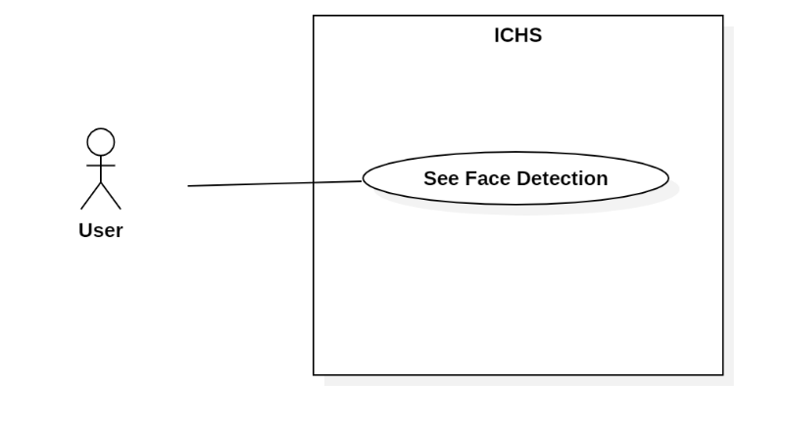

Figure : <User> See Face Detection

|  |  |  |  |
| --- | --- | --- | --- |
| **USE CASE – UC_32** | | | |
| **Use Case No.** | 32 | **Use Case Version** | 1.0 |
| **Use Case Name** | See Face Detection | | |
| **Author** | TuyenNQ | | |
| **Date** | 08/08/2019 | **Priority** | Normal |
| **Actor:**   * User   **Summary:**   * This use case allows the user to see face detection in streaming video from the selected camera.   **Goal:**   * User see face detection in streaming video.   **Triggers:**   * User clicks on “View zone” button. * User clicks on “View camera” button * User sends see count people command.   **Preconditions:**   * User login success. * User is at” Camera” page.   **Post Conditions:**   * **Success:** User view streaming camera. * **Fail:** System displays error message.   **Main Success Scenario:**   |  |  |  | | --- | --- | --- | | **Step** | **Actor Action** | **System Response** | | 1 | User clicks on “View” button on store page. | System shows list all zone in store. | | 2 | User clicks on “View” button on zone page. | System shows list all camera in zone. | | 3 | User click on “View” button on camera detail page. | System shows camera. | | 4 |  | System shows box on streaming camera and detect face when face people near camera.  [Exception 1] |   **Alternative:** N/A.  **Exception:**   |  |  |  | | --- | --- | --- | | **No** | **Cause** | **System Response** | | 1 | Network problem. | System shows error message. |   **Relationships:** N/A  **Business Rules:**   * System face detection when face is near camera. * Face detection suggest age and gender for people. | | | |

Table : <User> See Face Detection

## **<User> View Stream Heatmap**

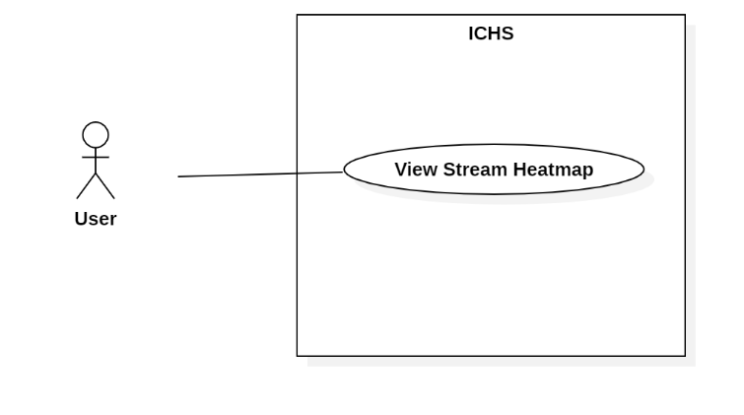

Figure : <User> View Stream Heatmap

|  |  |  |  |
| --- | --- | --- | --- |
| **USE CASE – UC_33** | | | |
| **Use Case No.** | 33 | **Use Case Version** | 1.0 |
| **Use Case Name** | View Streaming Heatmap | | |
| **Author** | TuyenNQ | | |
| **Date** | 08/08/2019 | **Priority** |  |
| **Actor:**   * User   **Summary:**   * This use case allows the user to view the streaming heatmap from the selected camera.   **Goal:**   * User view streaming heatmap from camera.   **Triggers:**   * User clicks on “Store” button. * User clicks on “view zone” button. * User clicks on “view camera” button. * User clicks on “heatmap” button of the camera. * User sends view streaming camera command.   **Preconditions:**   * User login success. * User is at “Camera” page.   **Post Conditions:**   * **Success:** User view streaming camera. * **Fail:** System displays error message.   **Main Success Scenario:**   |  |  |  | | --- | --- | --- | | **Step** | **Actor Action** | **System Response** | | 1 | User clicks on “store” button. | System shows list of store of user. | | 2 | User clicks on “View zone” button. | System shows list of zone in this store that user clicks on. | | 3 | User clicks on “view camera” button. | System shows that camera user clicks on. | | 4 | User clicks “heatmap” button. | System shows heatmap on this camera.  [Exception 1] |   **Alternative:** N/A.  **Exception:** N/A.   |  |  |  | | --- | --- | --- | | **No** | **Cause** | **System Response** | | 1 | Network problem. | System shows error message. |   **Relationships:** N/A.  **Business Rules:**   * Heatmap shows dots on streaming camera. | | | |

Table : <User> View Stream Heatmap

## **<User> View Report**

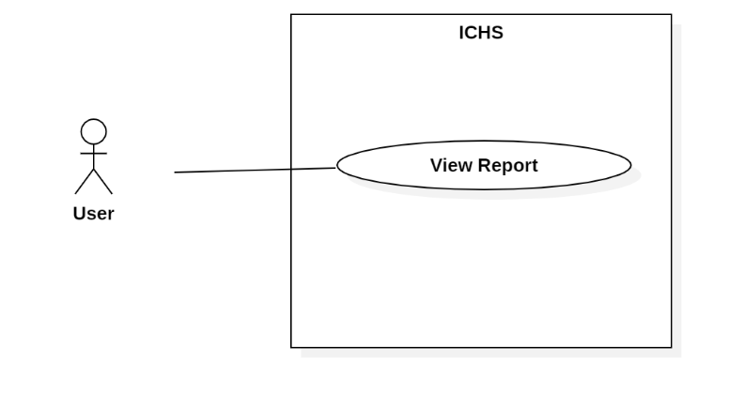

Figure : <User> View Report

|  |  |  |  |
| --- | --- | --- | --- |
| **USE CASE – UC_34** | | | |
| **Use Case No.** | 34 | **Use Case Version** | 1.0 |
| **Use Case Name** | View Report | | |
| **Author** | TuyenNQ | | |
| **Date** | 08/08/2019 | **Priority** |  |
| **Actor:**   * User   **Summary:**   * This use case allows the user to view report from the selected camera.   **Goal:**   * User view streaming video from camera.   **Triggers:**   * User clicks the thumbnail of the camera. * User sends view streaming camera command.   **Preconditions:**   * User login success. * User is at” Camera” page.   **Post Conditions:**   * **Success:** User view streaming camera. * **Fail:** System displays error message.   **Main Success Scenario:**   |  |  |  | | --- | --- | --- | | **Step** | **Actor Action** | **System Response** | | 1 | User clicks thumbnail of the selected camera in Camera page. | System displays the selected camera page and shows streaming video.  [Exception 1] |   **Alternative:** N/A.  **Exception:**   |  |  |  | | --- | --- | --- | | **No** | **Cause** | **System Response** | | 1 | Network problem. | System shows error message. |   **Relationships:** N/A.  **Business Rules:**   * View report following store, zone and camera. | | | |

Table : <User> View Report

## **<User> Preview heatmap in time**

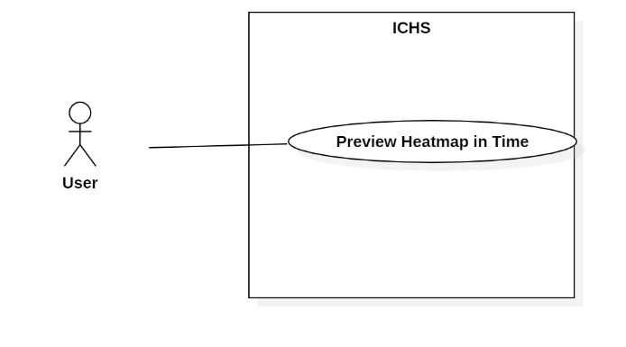

Figure : <User> View Heatmap

|  |  |  |  |
| --- | --- | --- | --- |
| **USE CASE – UC_35** | | | |
| **Use Case No.** | 35 | **Use Case Version** | 1.0 |
| **Use Case Name** | Preview Heatmap in Time | | |
| **Author** | TuyenNQ | | |
| **Date** | 08/08/2019 | **Priority** |  |
| **Actor:**   * User   **Summary:**   * This use case allows the user to view the streaming video from the selected camera and preview heatmap.   **Goal:**   * User view history heatmap.   **Triggers:**   * User clicks on “Store” button. * User clicks on “view zone” button. * User clicks on “view camera” button. * User clicks on “preview heatmap” button. * User sends view streaming camera command.   **Preconditions:**   * User login success. * User is at “Camera” page.   **Post Conditions:**   * **Success:** User view streaming camera. * **Fail:** System displays error message.   **Main Success Scenario:**   |  |  |  | | --- | --- | --- | | **Step** | **Actor Action** | **System Response** | | 1 | User clicks on “store” button. | System shows list of store of user. | | 2 | User clicks on “View zone” button. | System shows list of zone in this store that user clicks on. | | 3 | User clicks on “view camera” button. | System shows that camera user clicks on. | | 4 | User clicks on “preview heatmap” button. | System shows heatmap in history.  [Exception 1] |   **Alternative:** N/A.  **Exception:**   |  |  |  | | --- | --- | --- | | **No** | **Cause** | **System Response** | | 1 | Network problem. | System shows error message. |   **Relationships:** N/A  **Business Rules:**   * System must be show heatmap on per time. * Heatmap update every 1 minute. | | | |

Table : <User> Preview heatmap in Time

# **ARCHITECTURAL DIAGRAM**

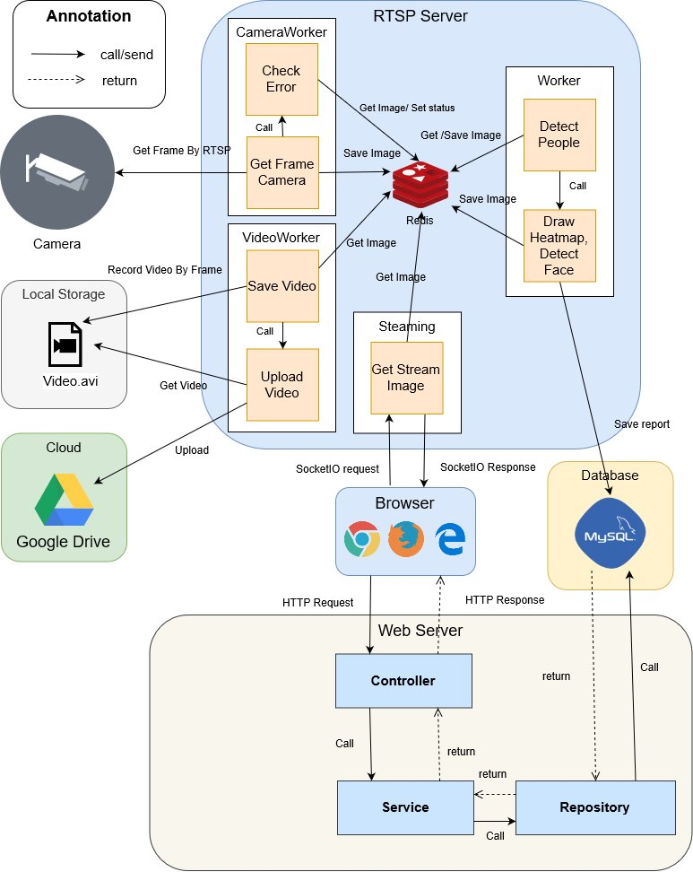

Figure : Architectural Diagram

# **COMPONENT DIAGRAM**

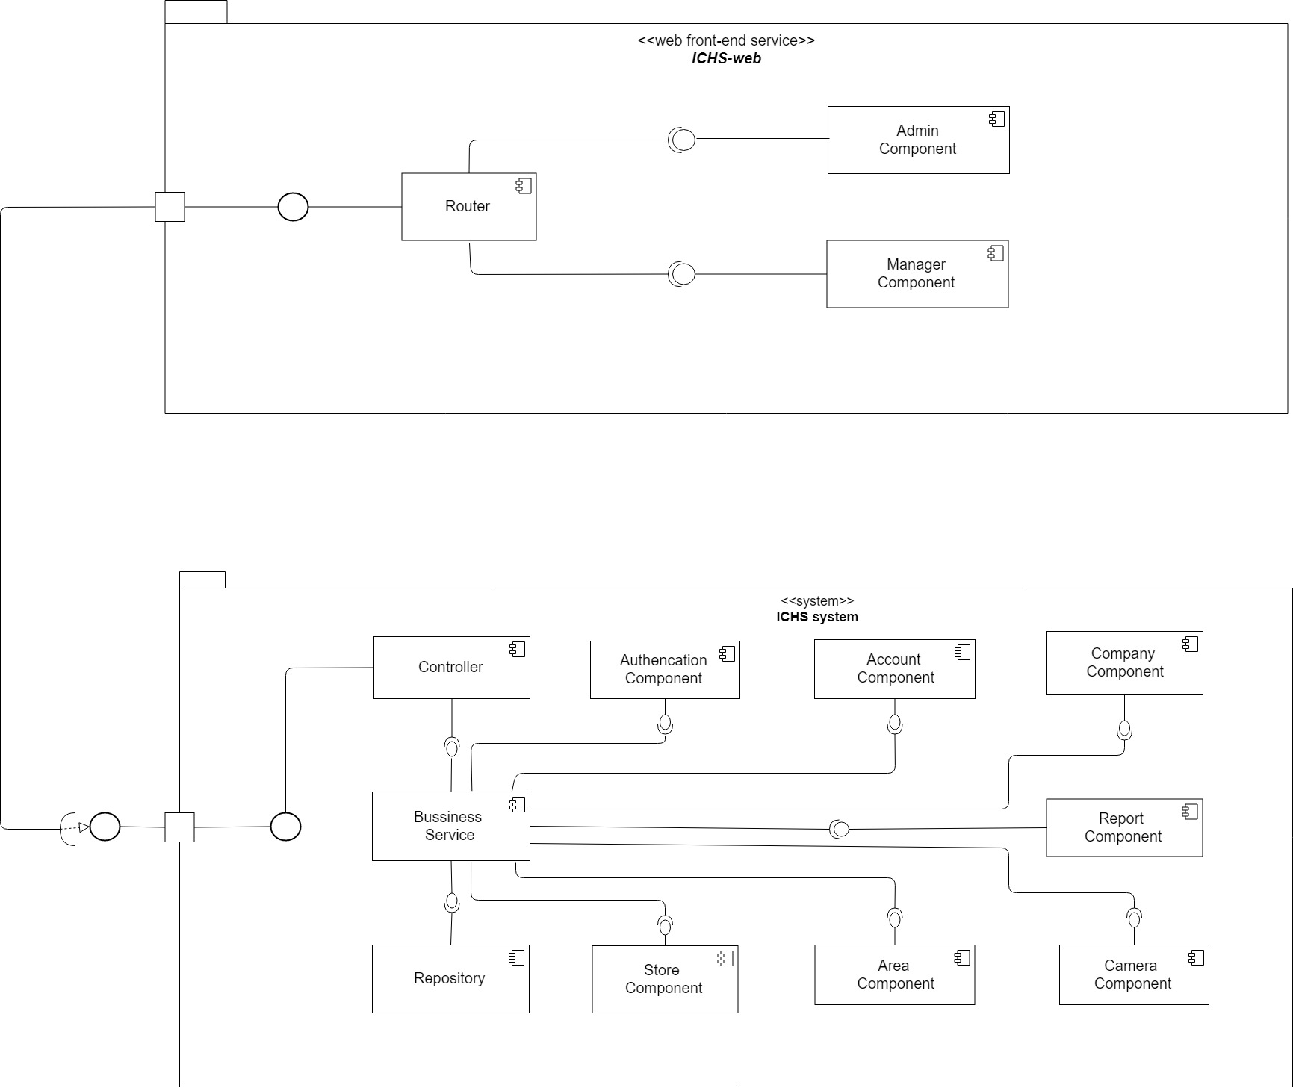

Figure : Component Diagram

| **Components Dictionary: Describes components** | |
| --- | --- |
| Business Service | Component which handles business process for Web Sever. Include |
| Repository | Component which handles storing and retrieving data from database. |
| Controller | Component which handles request and response, accept input, convert it to commands for model and view. |
| Router | Handle request and response, accept input and convert it to commands for back-end |
| Admin Component | Handle admin’s activities in the system |
| Manager Component | Handle manager’s activities in the system |

Table : Component Diagram Dictionary

# **CLASS DIAGRAM**

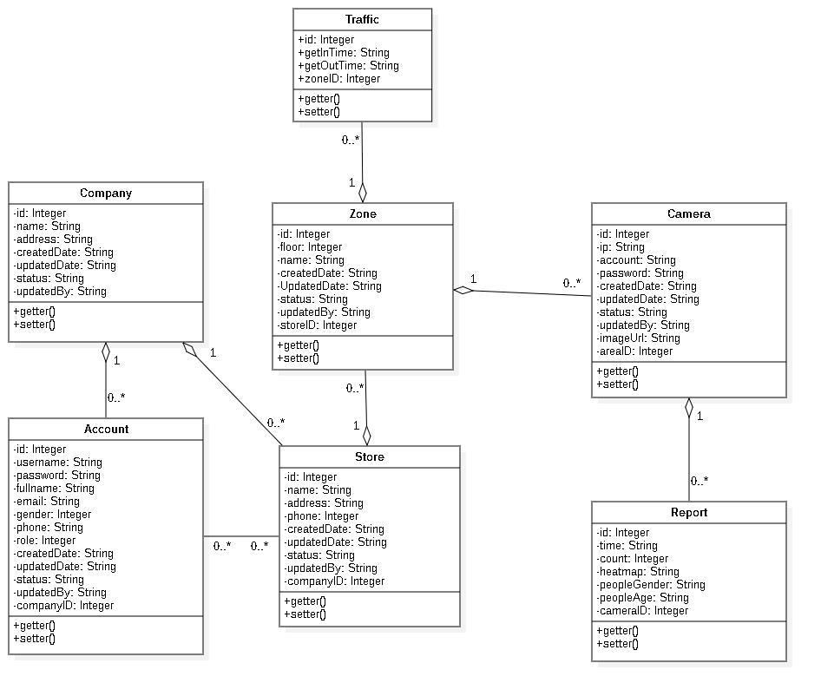

Figure : Class Diagram

|  |  |  |
| --- | --- | --- |
| **CLASS DICTIONARY: DESCRIBE CLASS** | | |
| **Class Name** | **Mapping column with Conceptual diagram** | **Description** |
| **Company** | Company | Contains the information of Company |
| **Account** | Account | Contains the information of Account |
| **Store** | Store | Contains the information of Store |
| **Zone** | Zone | Contains the information of Zone |
| **Camera** | Camera | Contains the information of Camera |
| **Report** | Report | Contains the information of Report |
| **Traffic** | Traffic | Contains the information of Traffic |

Table : Class Diagram Dictionary

# **ENTITY RELATIONSHIP DIAGRAM**

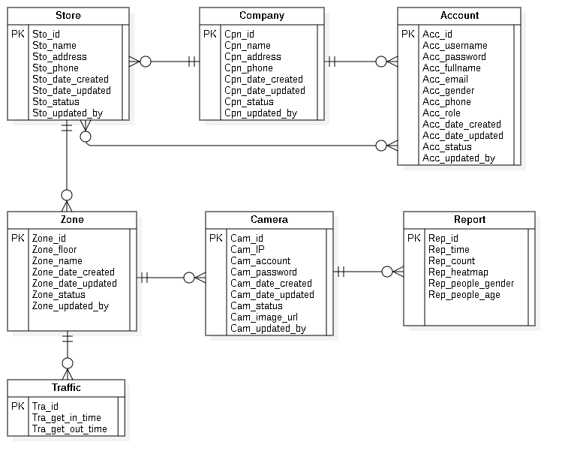

Figure : Entity Relationship Diagram

|  |  |  |
| --- | --- | --- |
| **Entity dictionary** | | |
| **Entity Name** | **Mapping column with Conceptual diagram** | **Description** |
| **Account** | Account | Contain the account information. |
| **Company** | Company | Contain the company information. |
| **Store** | Store | Contain the store information |
| **Zone** | Zone | Contain the zone information. |
| **Camera** | Camera | Contain the camera information. |
| **Report** | Report | Contain the report information. |
| **Traffic** | Traffic | Contain the traffic information. |

Table : Entity Relationship Diagram Dictionary

# **INTERACTION DIAGRAM**

## **Login**

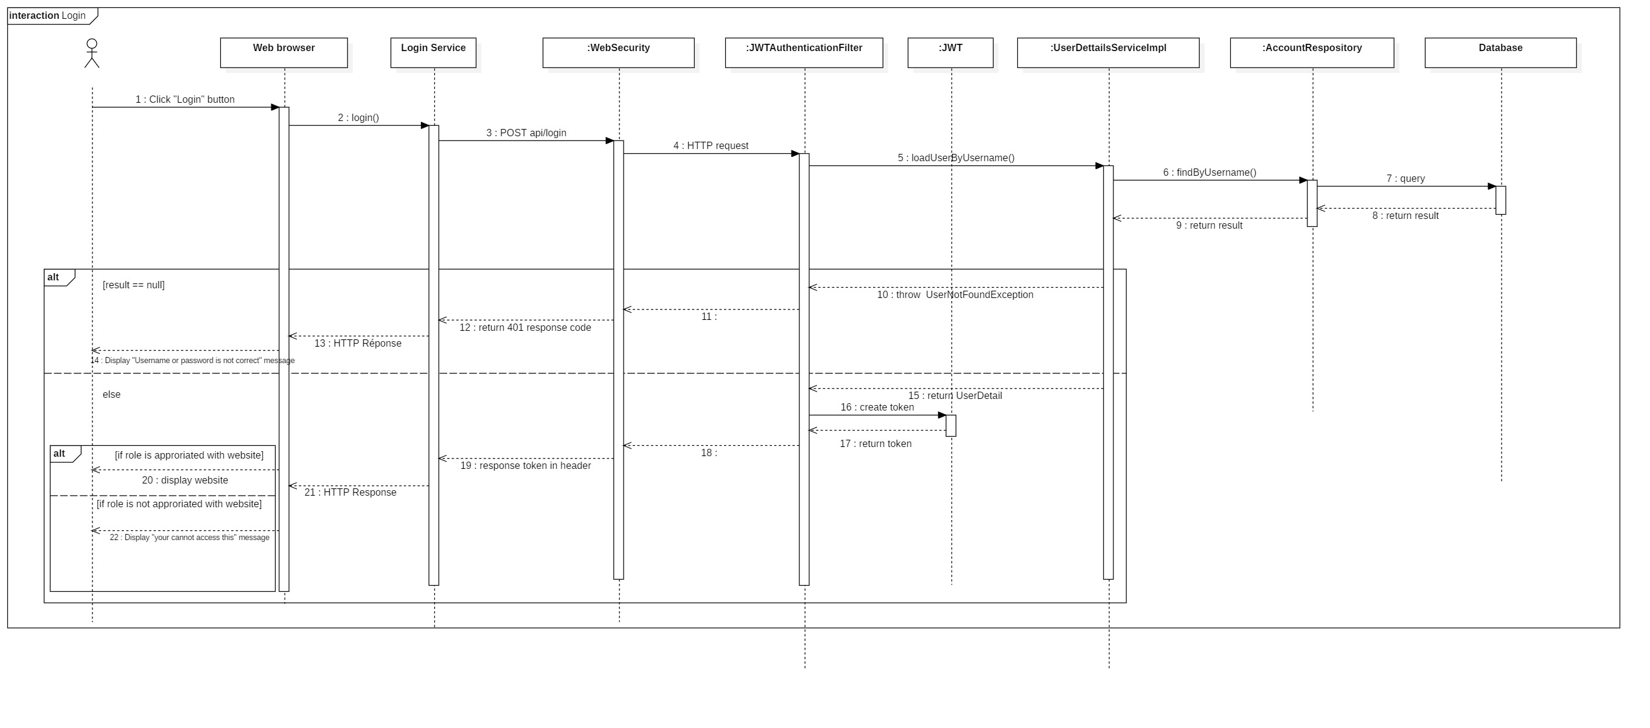

Figure : Sequence Diagram <Login>

## **Create Company**

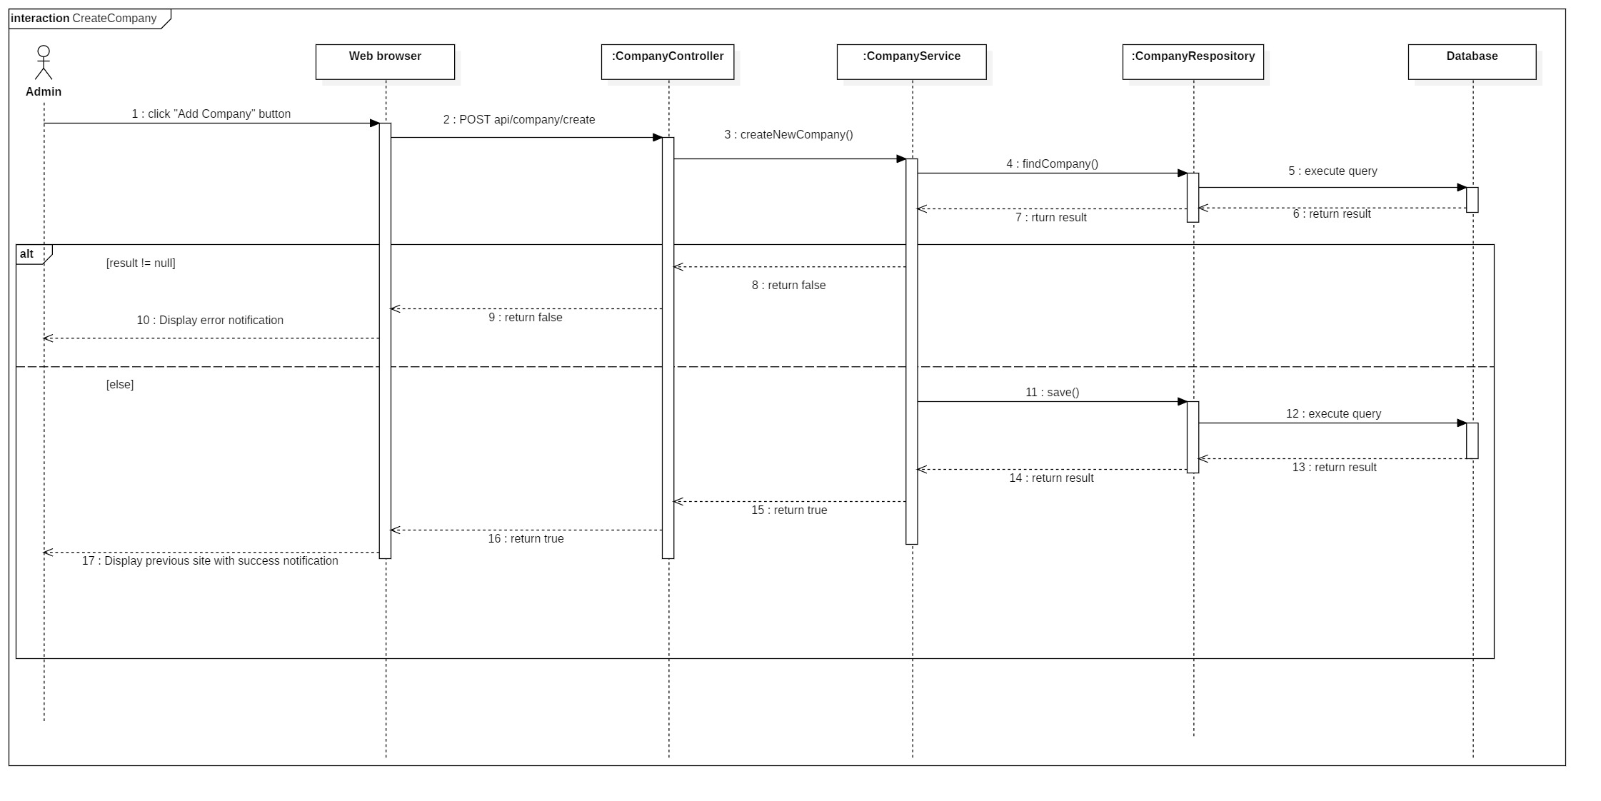

Figure : Sequence Diagram <Create Company>

## **Update Company**

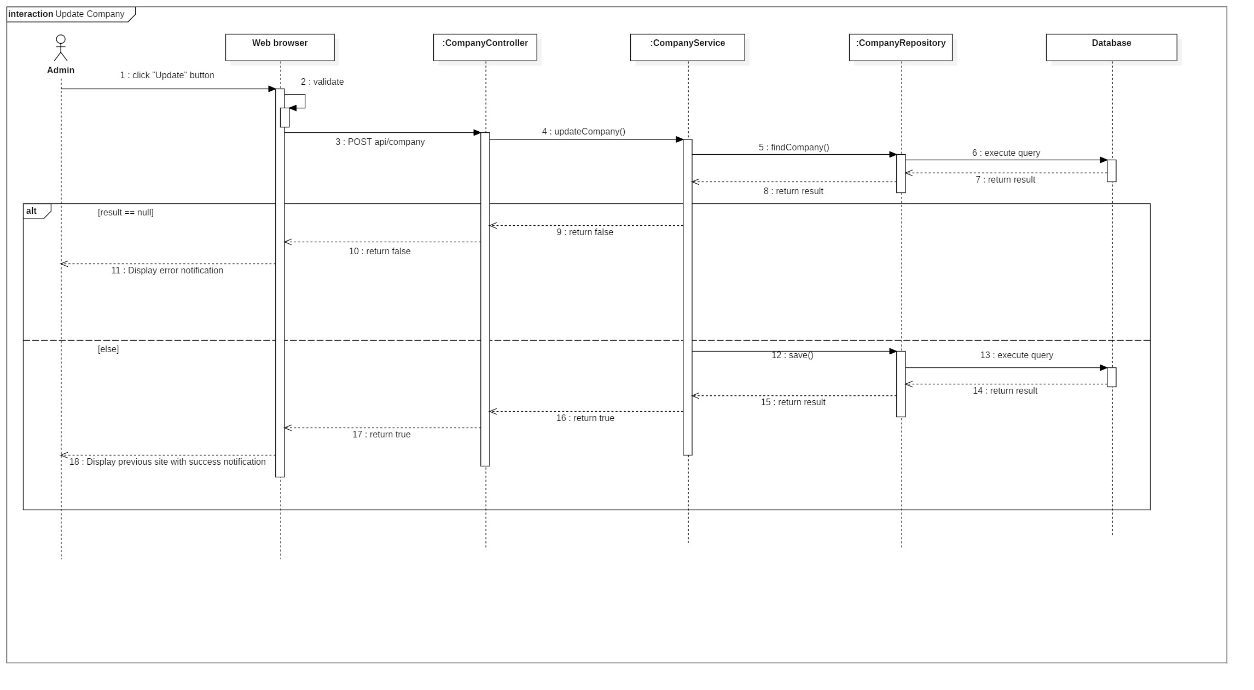

Figure : Sequence Diagram <Update Company>

## **Activate Company**

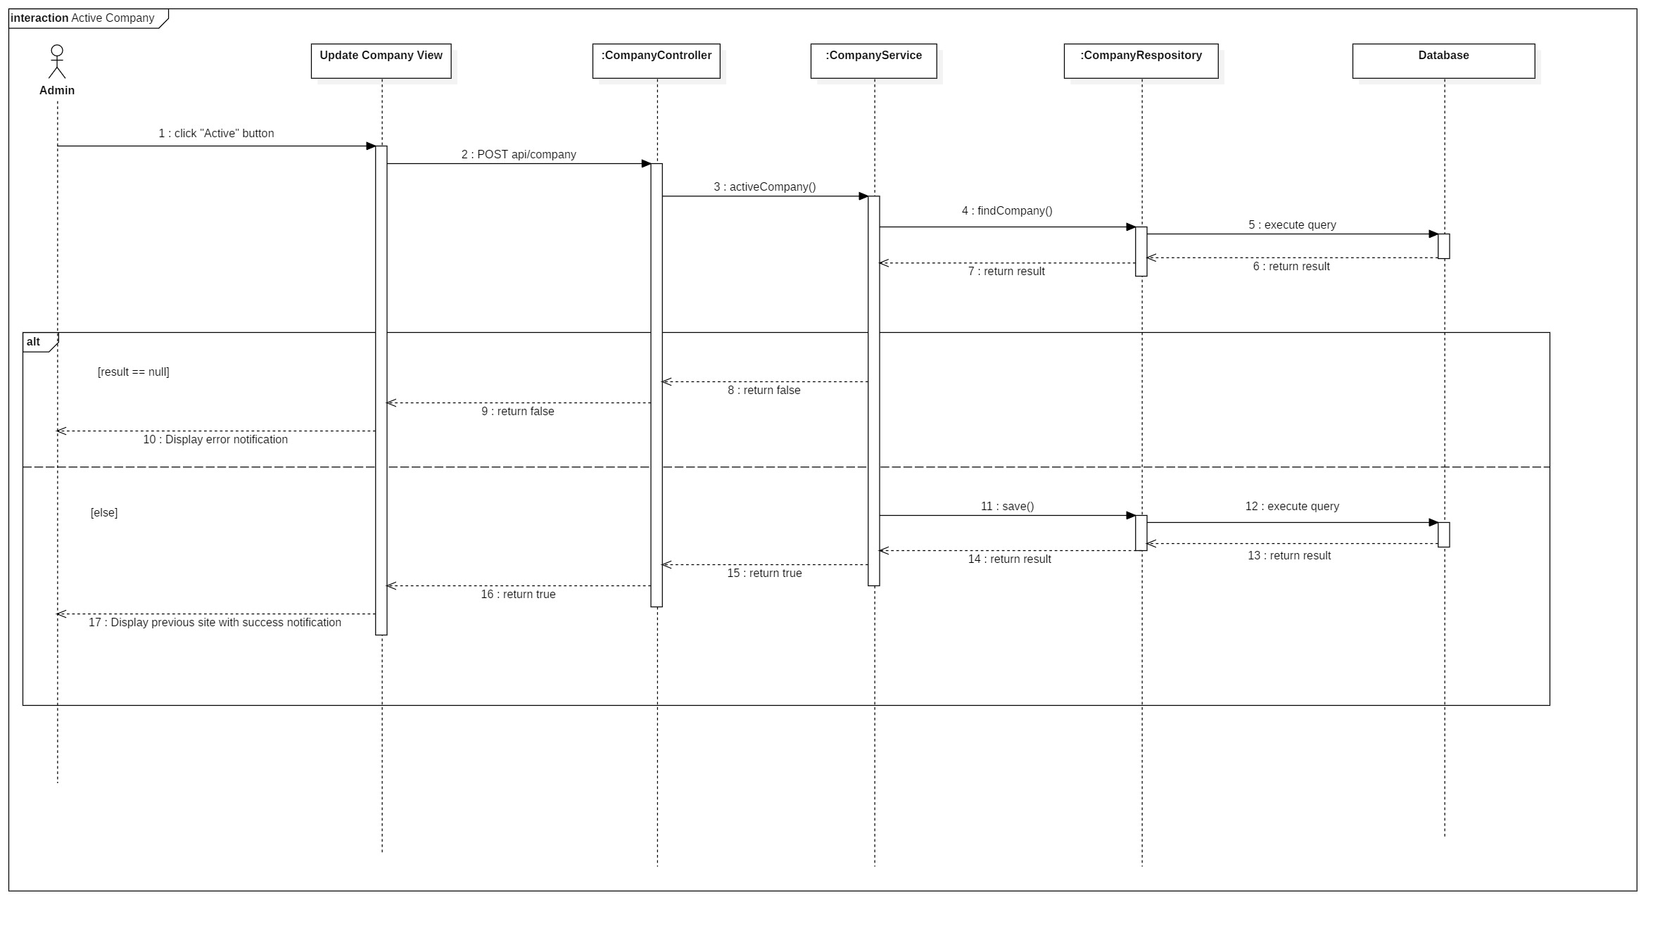

Figure : Sequence Diagram <Activate Company>

## **Deactivate Company**

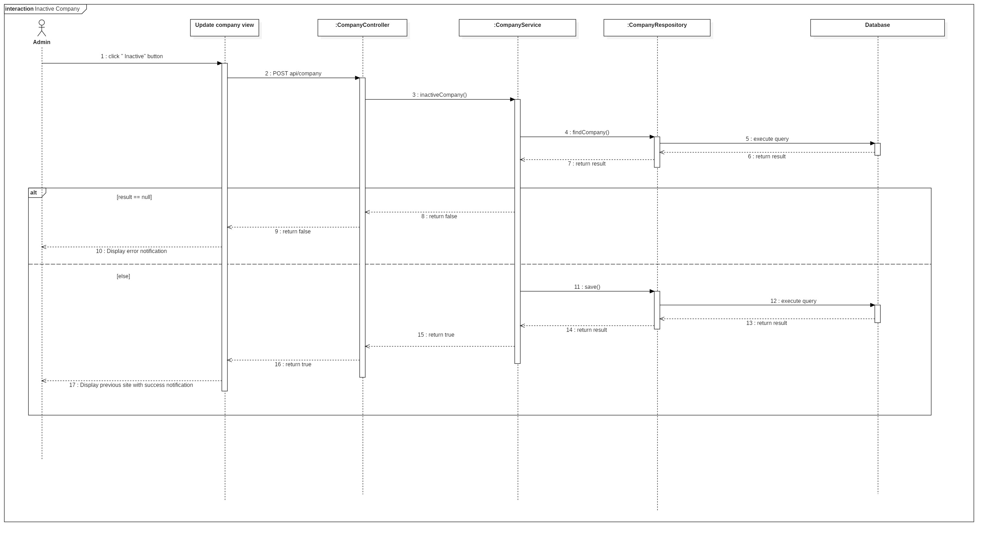

Figure : Sequence Diagram <Deactivate Company>

## **Search Company**

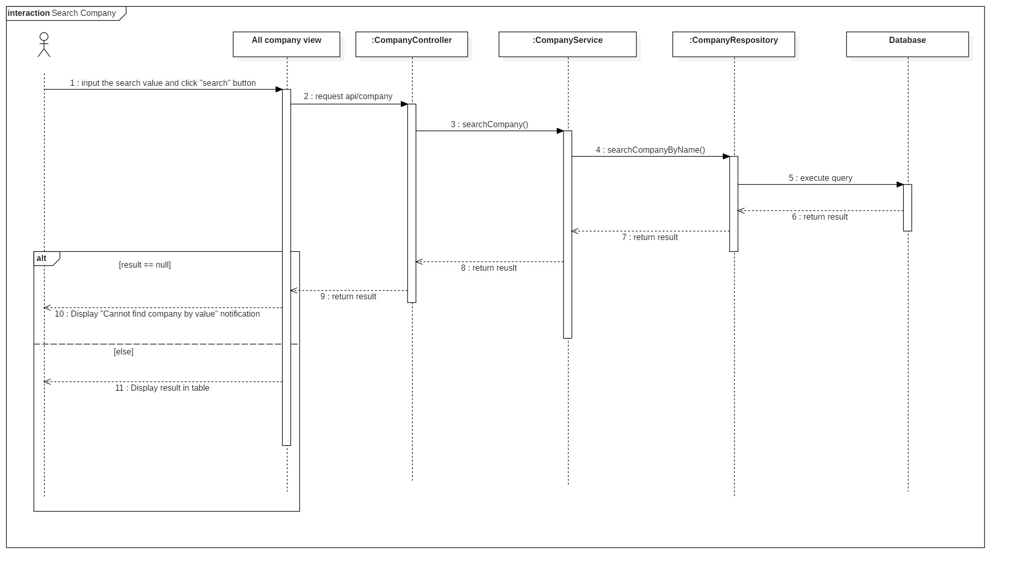

Figure : Sequence Diagram <Search Company>

## **Get report camera by time**

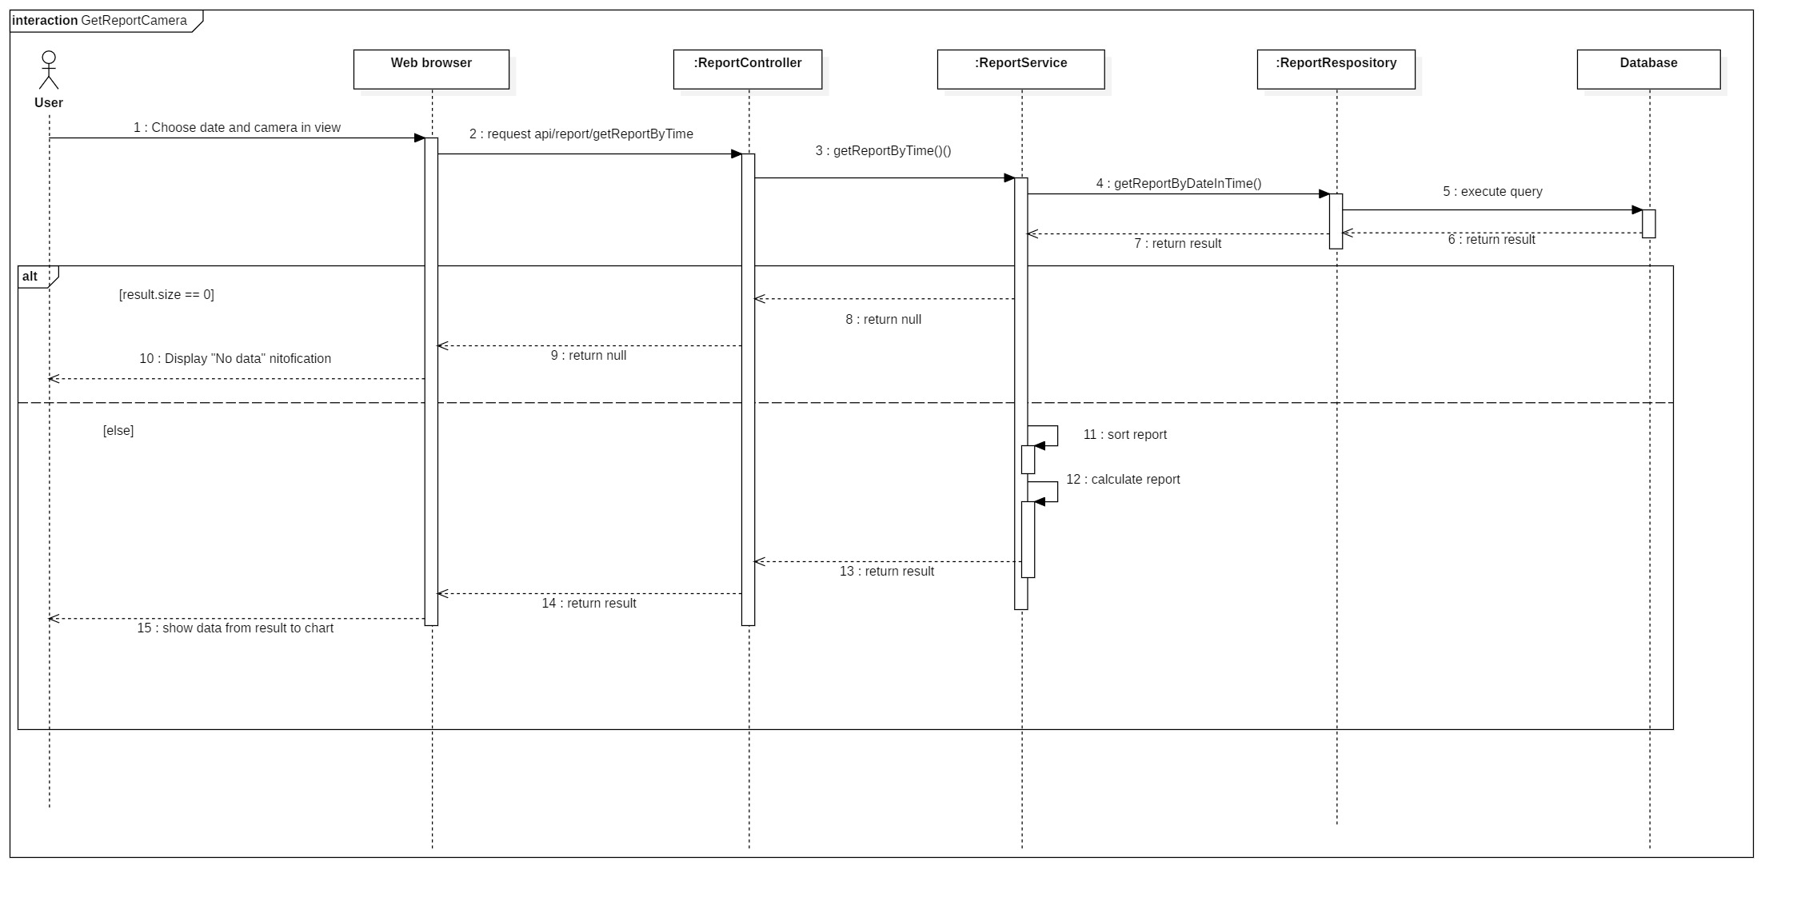

Figure : Sequence Diagram <Get report camera by time>

## **Get report zone by time**

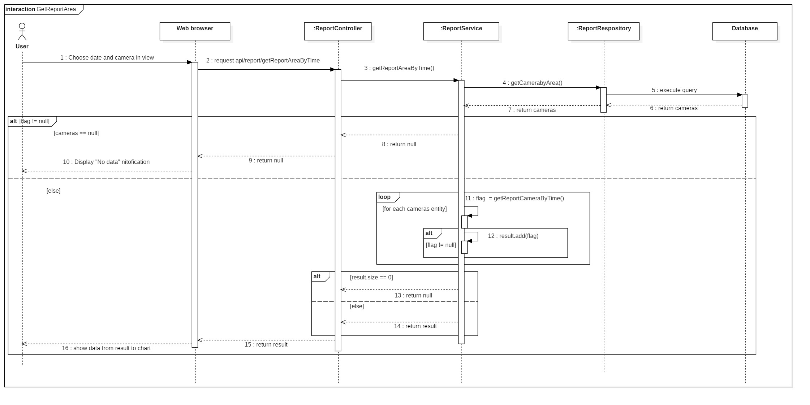

Figure : Sequence Diagram <Get report zone by time>

## **Get report store by time**

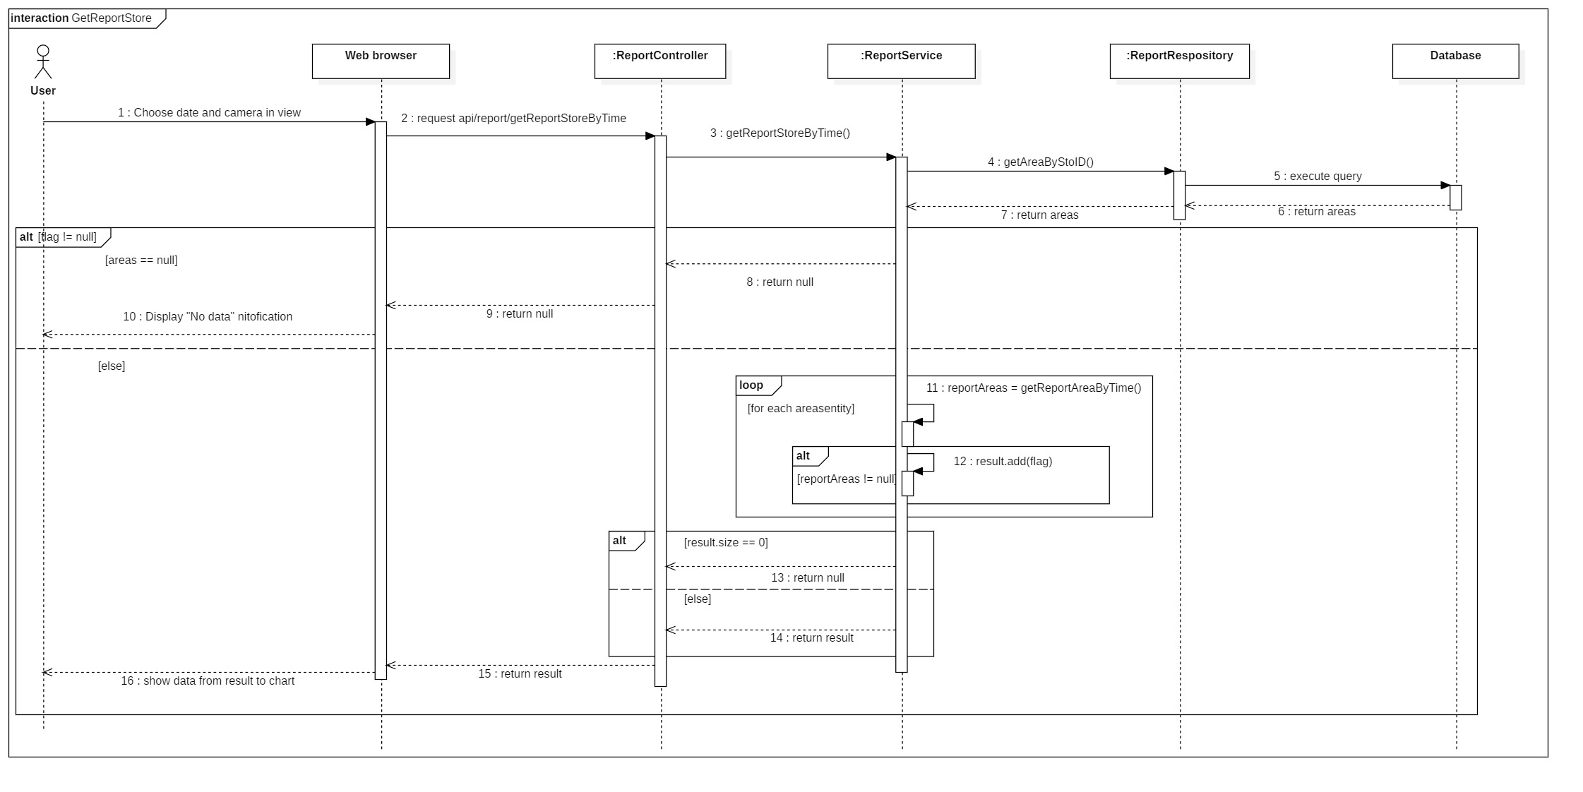

Figure : Sequence Diagram <Get report store by time>

# **PHYSICAL DIAGRAM**

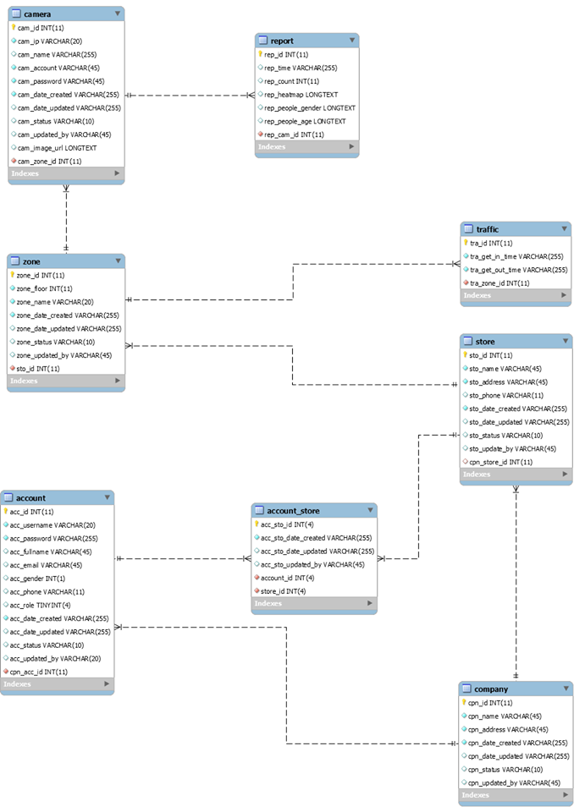

Figure : Physical Diagram

|  |  |
| --- | --- |
| **DATA DICTIONARY: DESCRIBE CONTENT OF ALL TABLES** | |
| **Table name** | **Description** |
| Company | Contains the company information. |
| Account | Contains the account information. |
| Store | Contains the store information. |
| Zone | Contains the zone information. |
| Camera | Contains the camera information. |
| Report | Contains the report information. |
| Account_Store | Contains relationship of account and store. |
| Traffic | Contains the traffic information. |

Table : Physical Diagram Dictionary

# **ARCHITECTURAL DIAGRAM FRAMEWORK**

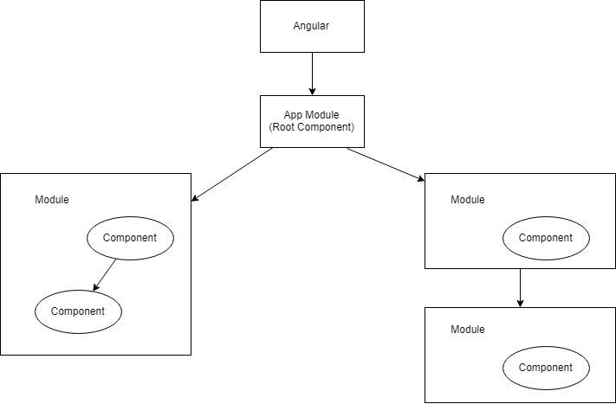

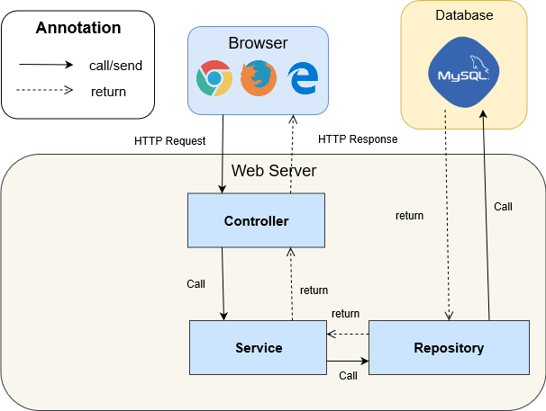

Figure : Architectural Diagram Framework

# **ALGORITHMS**

## **Faster RCNN**

### **Definition**

Faster RCNN is one of the most well-known objects detection networks which have 3 neural networks (Feature Network, Region Proposal Network, Detection Network). It is very useful for detecting object.

### **Define problems**

We don’t have experience of training AI for detecting people. Because people is object that needed detect so It need a big data set to train for many posture. So we decide to use TensorFlow API that use this algorithms.

### **Solution**

we decide to use TensorFlow API that use this algorithm.

Faster RCNN is Algorithms that TensorFlow API is using for detect object in image.

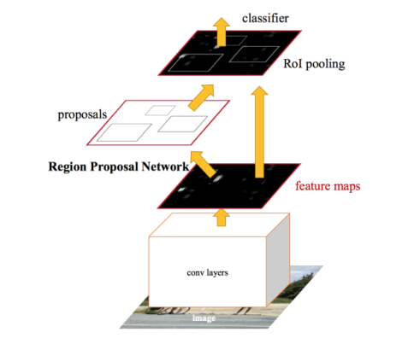

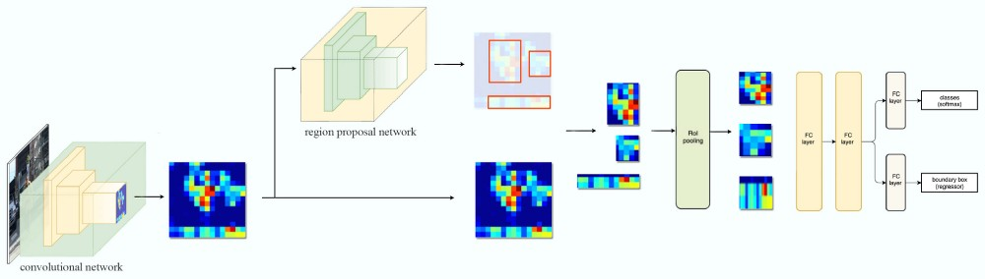

Figure : Faster RCNN 1

Steps:

1. Take image to Region Proposal Network (RPN) to get Region Proposal which has ability that contain object.
2. By RPN, we can define which box have object and by ROI Pooling to convert image to fixed size image.
3. After get fixed image, classify object in image and return 2 result: class which is type of object and bounding boxes.

* **Region Proposal Network**

Input is image and output are Region Proposal which is rectangle. Instead of using (x center, y center, width, height), RPN detect Region Proposal by using Anchor and create anchor box with 4 parameters (x min, y min, x max, y max)

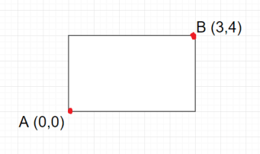

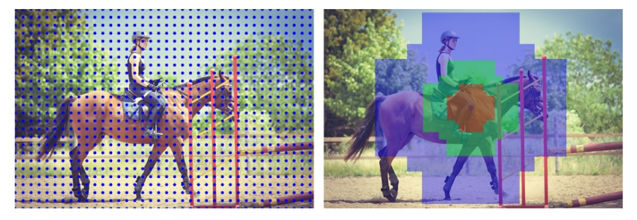

Figure : Faster RCNN 2

## **Draw Heatmap**

### **Definition**

Using LinearSegmentedColormap to create color map and use it to define what color based on grayscale image.

### **Define problem**

Color must be changed based on long people stay in camera

### **Solution**

Use dot image to draw on grayscale image.



Figure : Draw Heatmap <Dot Image>

And create a heatmap color image in local storage.



Figure : Draw Heatmap <Color Range>

We will set list of dots in a white image that it will become grayscale image and change its color based on how black it is.

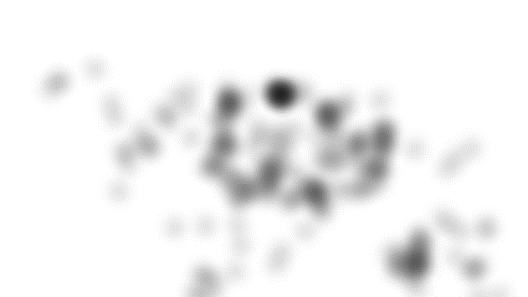 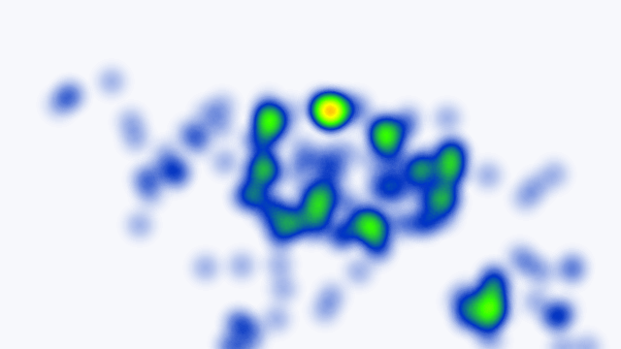

Figure : Draw Heatmap <Heatmap Color Image>

## **Face Detection**

### **Definition**

The Haar-like algorithm is also used for feature selection or feature extraction for an object in an image, with the help of edge detection, line detection, centre detection for detecting eyes, nose, mouth, etc. in the picture.

### **Define problem**

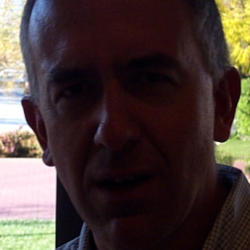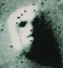

Figure : Face Detection

Light, masked, special emotion, looks like face ...

### **Solution**

Featured of Haar-like

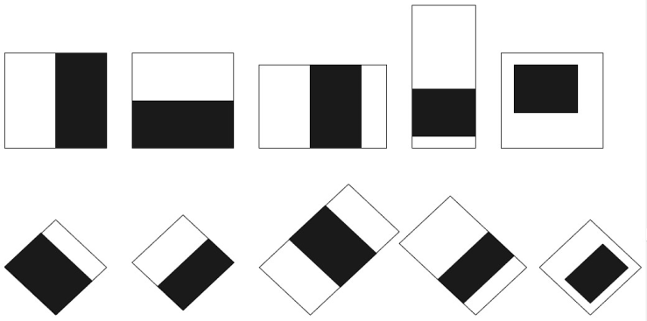

Figure : Face Detection <Haar-Like> 1

Haar-like algorithm give the coordinates of x, y, w, h which makes a rectangle box in the picture to show the location of the face or we can say that to show the region of interest in the image. After this, it can make a rectangle box in the zone of interest where it detects the face.

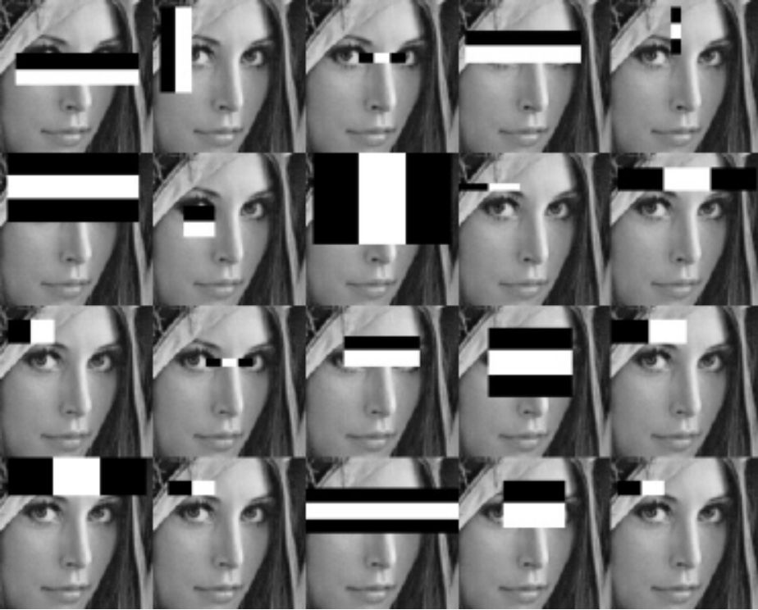

Figure : Face Detection <Haar-Like> 2

# **FUTURE PLAN**

Divide face detection to one specific camera and use that camera to count people come in shop/store.

# **DIAGRAM EXPLANATION**

## **CLASS DIAGRAM EXPLANATION**

### **Account**

|  |  |  |  |
| --- | --- | --- | --- |
| Attribute | Type | Visibility | Description |
| Id | Integer | Private | Unique identifier of an account |
| Username | String | Private | Username of Account |
| Password | String | Private | Password of Account |
| Email | String | Private | Email of Account |
| Gender | Integer | Private | Gender of Account |
| Phone | Integer | Private | Phone number of Account |
| Role | Integer | Private | Role of Account |
| CreatedDate | String | Private | Date when account is created |
| UpdatedDate | String | Private | Date when account is updated |
| Status | String | Private | Status of account |
| UpdatedBy | String | Private | Which username updates account |
| CompanyID | Integer | Private | Contain information of the mentioned attribute |
| Method | **Return Type** | **Visibility** | **Description** |
| getter | DataType | Public | Get value for attribute |
| Setter | Void | Public | Set value for attribute |

Table : Class Diagram Explanation <Account>

### **Company**

|  |  |  |  |
| --- | --- | --- | --- |
| Attribute | Type | Visibility | Description |
| Id | Integer | Private | Unique identifier of a company |
| Name | String | Private | Name of company |
| Address | String | Private | Address of company |
| CreatedDate | String | Private | Date when company is created |
| UpdatedDate | String | Private | Date when company is updated |
| Status | String | Private | Status of company |
| UpdatedBy | String | Private | Which username updates company |
| Method | **Return Type** | **Visibility** | **Description** |
| getter | DataType | Public | Get value for attribute |
| Setter | Void | Public | Set value for attribute |

Table : Class Diagram Explanation <Company>

### **Store**

|  |  |  |  |
| --- | --- | --- | --- |
| Attribute | Type | Visibility | Description |
| Id | Integer | Private | Unique identifier of a store |
| Name | String | Private | Name of store |
| Address | String | Private | Address of store |
| Phone | Integer | Private | Phone of store |
| CreatedDate | String | Private | Date when store is created |
| UpdatedDate | String | Private | Date when store is updated |
| Status | String | Private | Status of store |
| UpdatedBy | String | Private | Which username updates store |
| CompanyID | Integer | Private | Contain information of the mentioned attribute |
| Method | **Return Type** | **Visibility** | **Description** |
| getter | DataType | Public | Get value for attribute |
| Setter | Void | Public | Set value for attribute |

Table : Class Diagram Explanation <Store>

### **Zone**

|  |  |  |  |
| --- | --- | --- | --- |
| Attribute | Type | Visibility | Description |
| Id | Integer | Private | Unique identifier of an zone |
| Floor | Integer | Private | Floor of zone |
| Name | String | Private | Name of zone |
| CreatedDate | String | Private | Date when zone is created |
| UpdatedDate | String | Private | Date when zone is updated |
| Status | String | Private | Status of zone |
| UpdatedBy | String | Private | Which username updates zone |
| StoreID | String | Private | Contain information of the mentioned attribute |
| Method | **Return Type** | **Visibility** | **Description** |
| getter | DataType | Public | Get value for attribute |
| setter | Void | Public | Set value for attribute |

Table : Class Diagram Explanation <Zone>

### **Camera**

|  |  |  |  |
| --- | --- | --- | --- |
| Attribute | Type | Visibility | Description |
| Id | Integer | Private | Unique identifier of a camera |
| Ip | String | Private | Ip of camera |
| Account | String | Private | Account of camera |
| Passsword | String | Private | Password of camera |
| CreatedDate | String | Private | Date when camera is created |
| UpdatedDate | String | Private | Date when camera is updated |
| Status | String | Private | Status of camera |
| ImageUrl | String | Private | Image url of camera |
| UpdatedBy | String | Private | Which username updates camera |
| ZoneID | Integer | Private | Contain information of the mentioned attribute |
| Method | **Return Type** | **Visibility** | **Description** |
| getter | DataType | Public | Get value for attribute |
| Setter | Void | Public | Set value for attribute |

Table : Class Diagram Explanation <Camera>

### **Report**

|  |  |  |  |
| --- | --- | --- | --- |
| Attribute | Type | Visibility | Description |
| Id | Integer | Private | Unique identifier of a report |
| Time | String | Private | Time of report |
| Count | String | Private | Number of counted people |
| Heatmap | String | Private | The matrix heatmap of people |
| PeopleGender | String | Private | Number gender of people |
| PeopleAge | String | Private | Number age of people |
| CameraID | Integer | Private | Contain information of the mentioned attribute |
| Method | **Return Type** | **Visibility** | **Description** |
| getter | DataType | Public | Get value for attribute |
| Setter | Void | Public | Set value for attribute |

Table : Class Diagram Explanation <Report>

### **Traffic**

|  |  |  |  |
| --- | --- | --- | --- |
| Attribute | Type | Visibility | Description |
| Id | Integer | Private | Unique identifier of traffic |
| GetInTime | String | Private | Time when get in |
| GetOutTime | String | Private | Time when get out |
| ZoneID | Integer | Private | Contain information of the mentioned attribute |
| Method | **Return Type** | **Visibility** | **Description** |
| getter | DataType | Public | Get value for attribute |
| Setter | Void | Public | Set value for attribute |

Table : Class Diagram Explanation<Traffic>